Programming project – Fault Tolerant CAD

In this assignment we will give a basic drawing application tool a collaborative fault tolerant environment written in java. The drawing tool can handle multiple clients. The server side has a front end and server replicas. When a client joins his window is updated with what has been drawn until now by other clients.

Implementation of TCP

The connection between replicas will be done using TCP because TCP is reliable. Its reliable because packets won’t get lost. The information that will be passed between the replicas is the TCPMessage class. TCPMessage is used to store a string, an object, a boolean and an int. The int is used to store a port number.

Implementation of the Server

When you start up the server you supply two port numbers, one for the server and another for the FrontEnd. You can also supply more for each other replica. The server then runs init which starts the statemachine. On the following page you will see a flow chart.

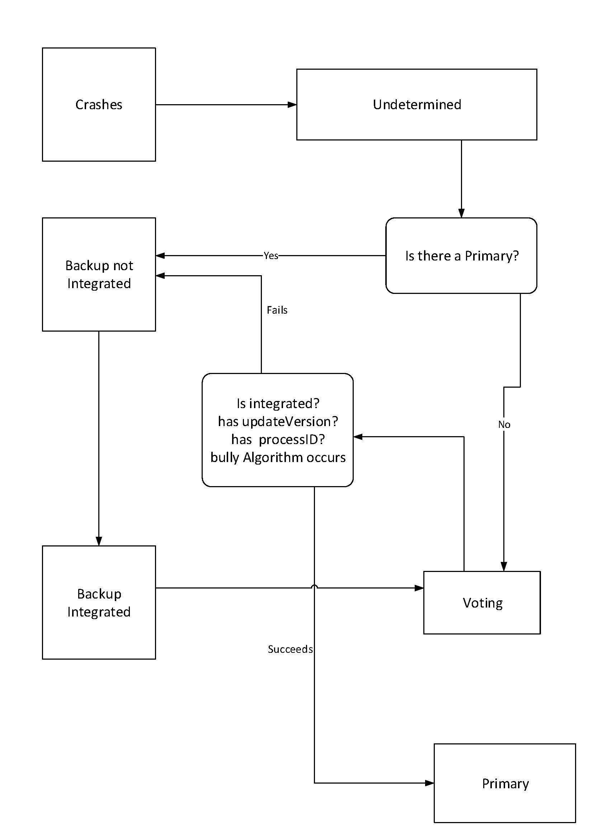

Management of Replica Managers

Replica servers communicate through TCP. The primary will be decided in the voting state. In voting we use bully algorithm to decide the primary. If primary crashes the other replicas will govoting state to select a new primary server through voting based on the servers variables integrated, updateVersion and processId.

Implementation of the Clients and FrontEnds

The connection between clients and frontends is UDP since we prioritized speed and performance over reliability. UDP is also stateless which makes it easier to implement for a stateless frontend.

Reflection

What we discarded during the course of this project is the idea of using TCP with the client and the server as it would cause problems down the line. Since tcp is stateful its hard to implement it as stateless and we would still need to implement reliability because with failure model. We learned a lot of team work skills while working on this project. In terms of distributed systems, we have a better understanding of what goes on between servers, clients and server replicas. Our Java has improved while coding with datagrams and streams. If we were going to do this again, we would have approached the connection between servers and server replicas differently because the bully algorithm was difficult to implement on our solution.

